Station 2 Protocol – The Six Phases of Eating (verbatim ) (Fletcher, 2017)

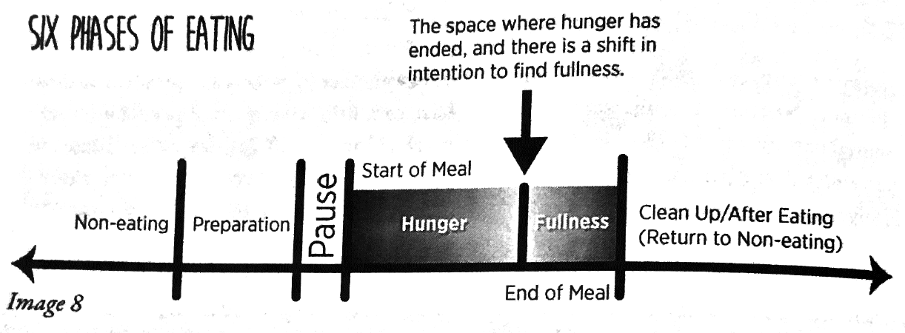
- Non-eating. In this phase, a person would not eat. There is no physical sense of hunger present. This would be represented by a hunger/fullness rating of 0. If hunger were present, the individual would move to the preparation phase.
- Preparation. This phase involves the selection of what to eat. It is a daunting task. If hunger is present, there may be a desire to snack before a meal. However, hunger may not always be present – for example, when food shopping for the week. Many people like engaging in meal preparation when hunger is slight or not present, because they find they are better able to make choices that are balanced and that nourish the body.
- Pause. This phase happens before eating. It is connected with you physical sense of hunger, but the pause does more. It connects you with your intention for self-kindness – or at least to not harm yourself.
- Eating. Awareness of your level of hunger (or fullness) is present. While eating, notice your direct sensory experience: sight, sound, smell, taste, touch, or how something feels. Keep in mind that your sensory experience also involves your body, such as hunger, fullness, satiety, feelings of energy, fatigue, wellness, or illness.
- End of meal. In this phase, you are aware that your physical hunger has ended and that fullness has started to emerge. If you keep eating, fullness will increase from the level of 1 (slight) to 4-6 (comfortable). If you continue eating, the level will increase past comfort to an uncomfortable level 7+.
Clean up and return to non-eating. In this phase you have some level of fullness, which is likely why you stopped eating. However, it is also likely you are surrounded by sensory temptation. This make the Clean-Up Phase different from the Non-Eating Phase because it requires an additional awareness of the environmental cues that may prompt a person to keep eating, which is called Mindless Eating.

Station 2 Protocol – The Mindful Eating Map (verbatim) (Fletcher, 2017)

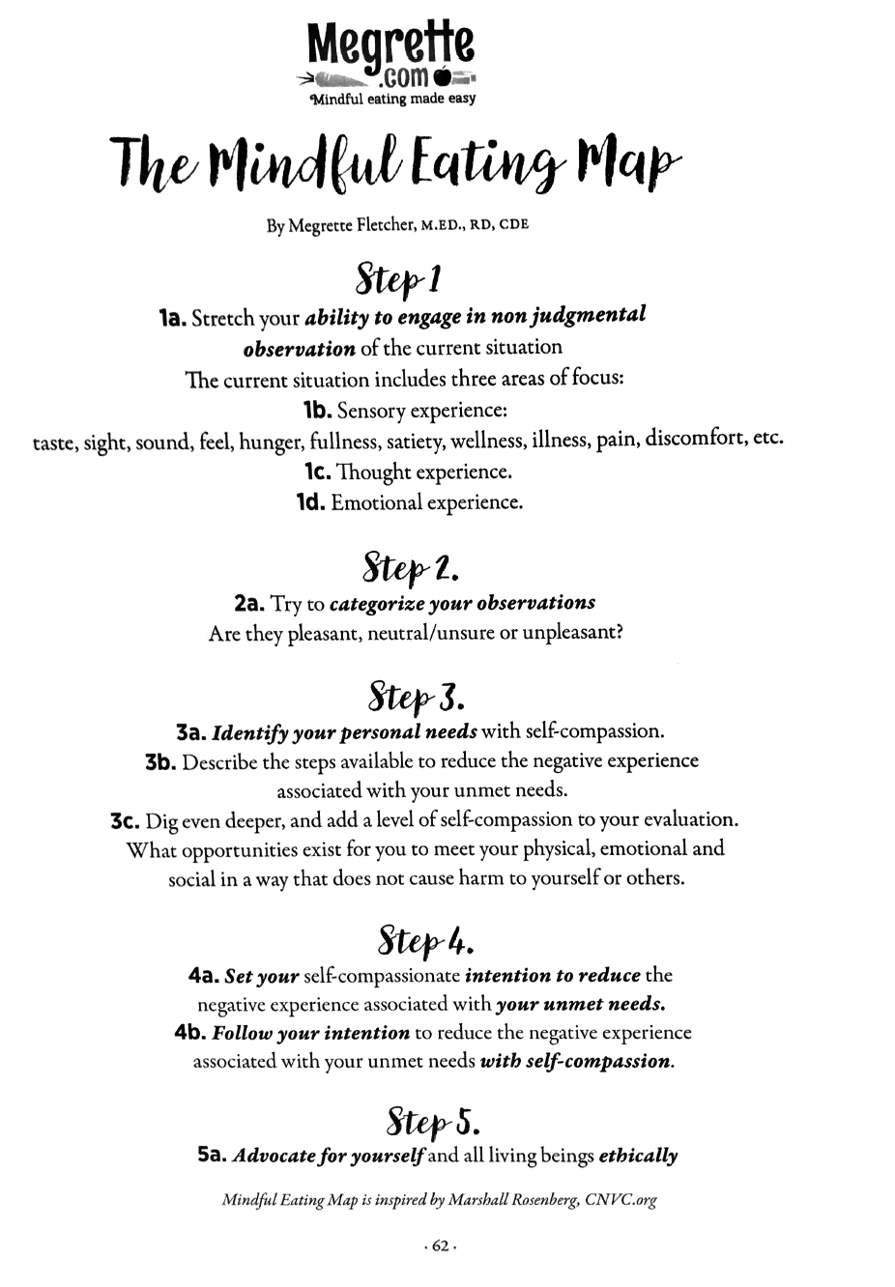
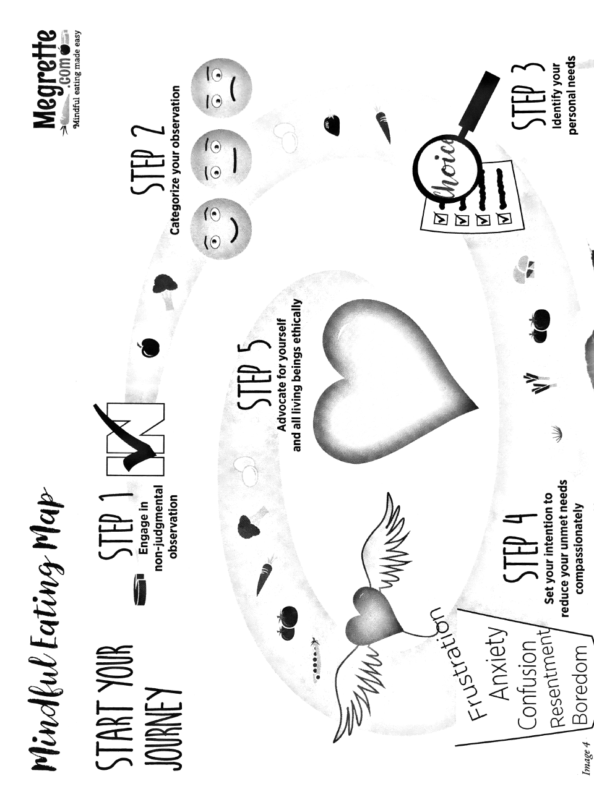
Station 2 Protocol – Hunger Scale (verbatim) (Fletcher, 2017).

