Station 1 Activity
Portion Size ‘Bingo’ – Bingo Board (verbatim) (Sustainable America, 2014).

Directions: Match the foods below to the appropriate portion sizes.

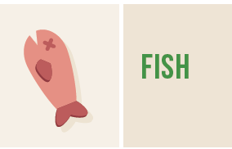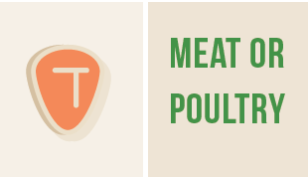

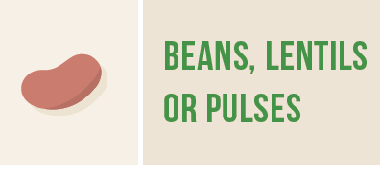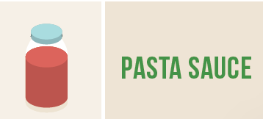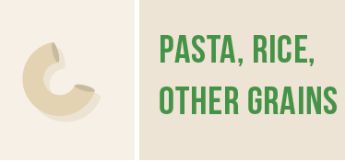

Portion Size ‘Bingo’ – Answer Key (verbatim) (Sustainable America, 2014).

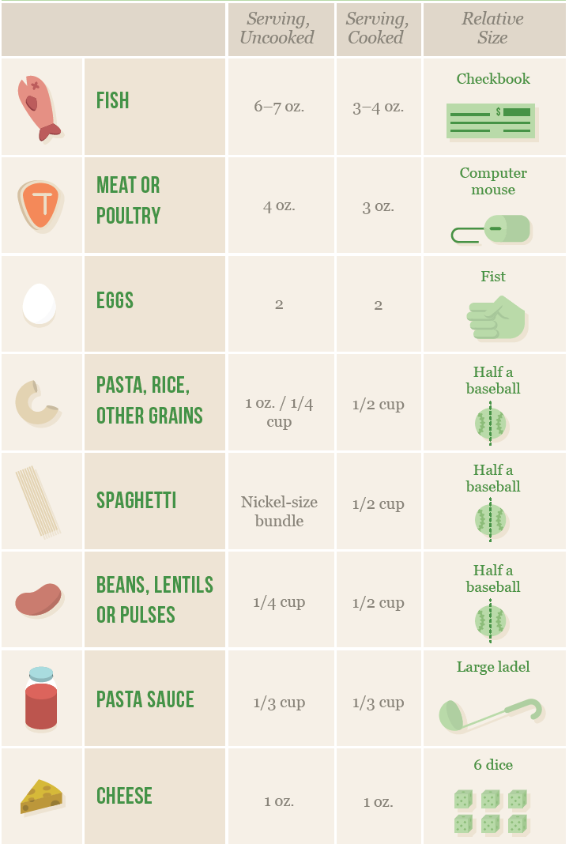
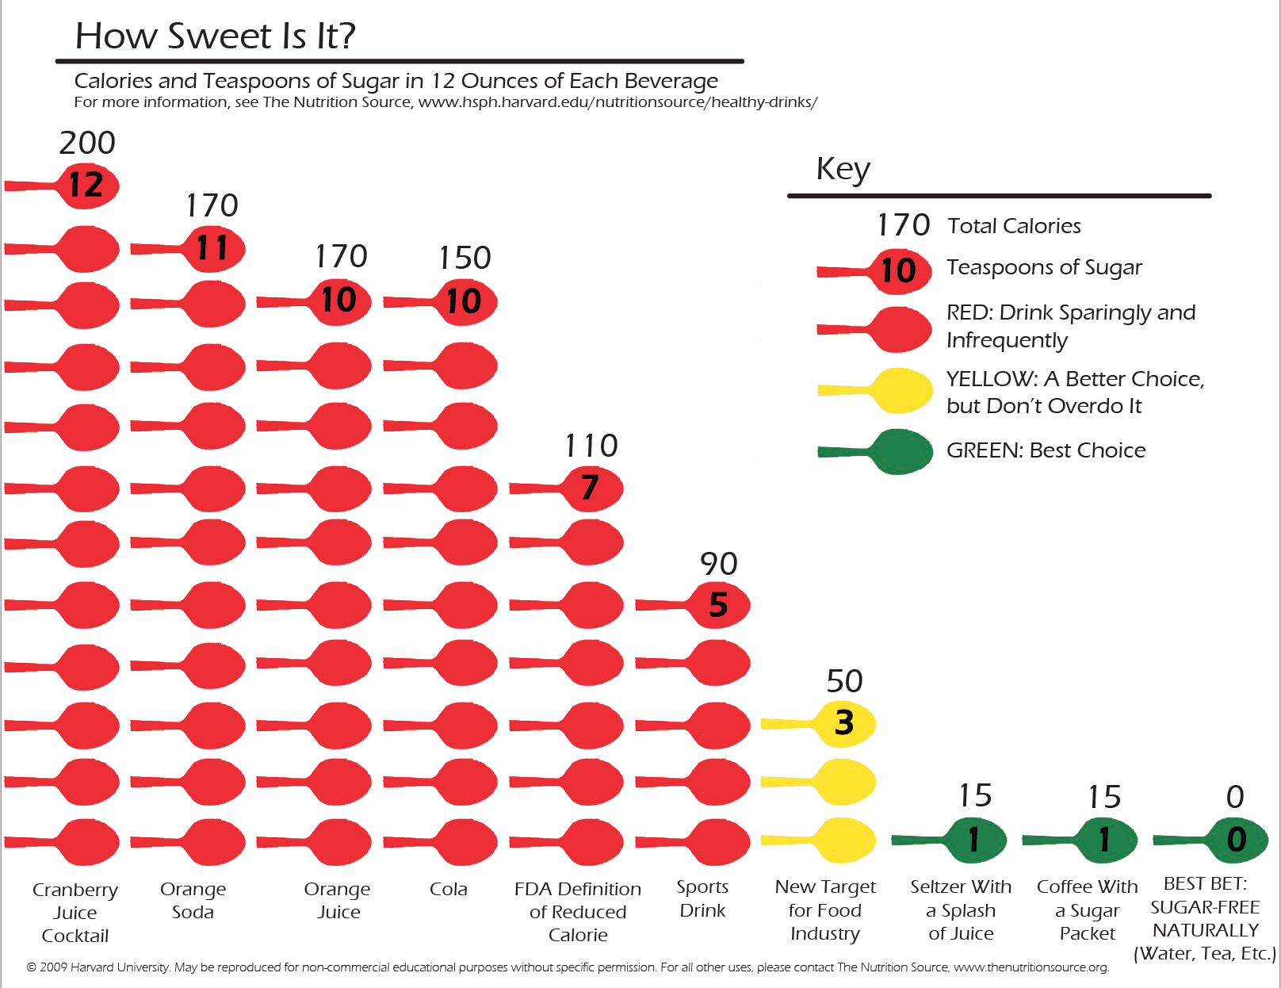
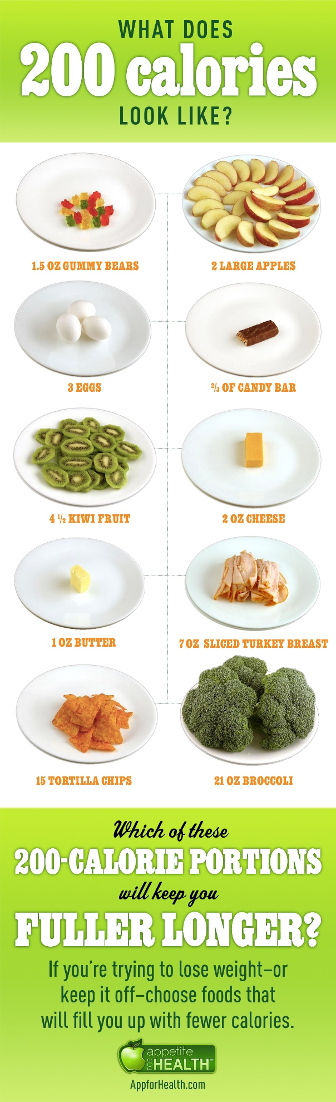

The truth about fats: the good, the bad, and the in-between

Avoid the trans fats, limit the saturated fats, and replace with essential polyunsaturated fats

From: Harvard Health Publishing, Harvard Medical School
https://www.health.harvard.edu/staying-healthy/the-truth-about-fats-bad-and-good

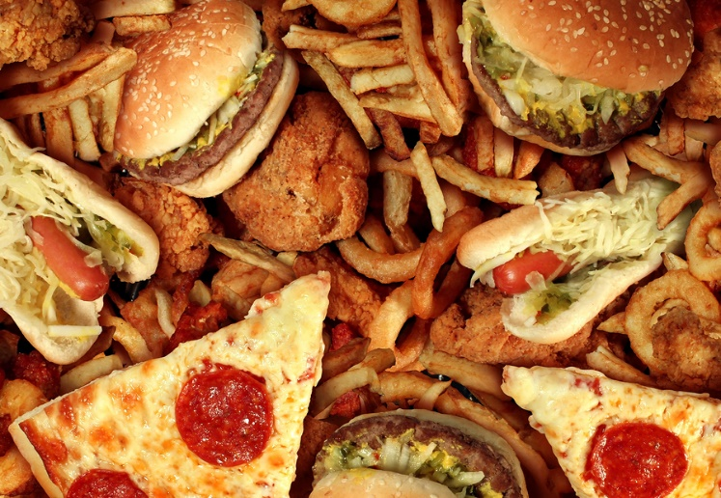
Bad Trans Fats:
The worst type of dietary fat is the kind known as trans fat. It is a byproduct of a process called hydrogenation that is used to turn healthy oils into solids and to prevent them from becoming rancid. Trans fats have no known health benefits and that there is no safe level of consumption. Therefore, they have been officially banned in the United States.

Saturated Fats:
Saturated fats are common in the American diet. They are solid at room temperature — think cooled bacon grease, but what is saturated fat? Common sources of saturated fat include red meat, whole milk and other whole-milk dairy foods, cheese, coconut oil, and many commercially prepared baked goods and other foods.

Is saturated fat bad for you? A diet rich in saturated fats can drive up total cholesterol, and tip the balance toward more harmful LDL cholesterol, which prompts blockages to form in arteries in the heart and elsewhere in the body. For that reason, most nutrition experts recommend limiting saturated fat to under 10% of calories a day.

Good monounsaturated and polyunsaturated fats
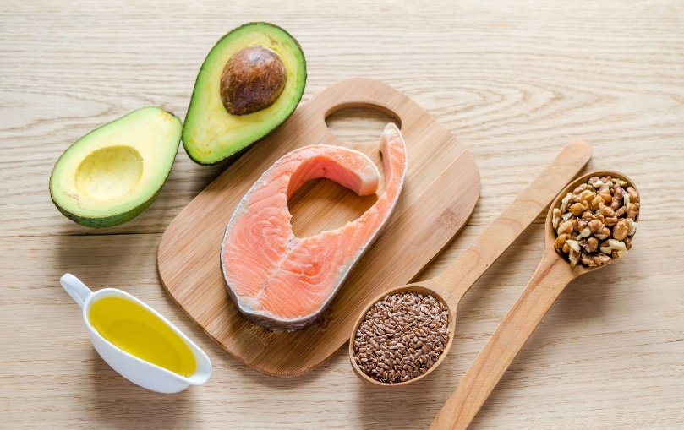
Good fats come mainly from vegetables, nuts, seeds, and fish. Healthy fats are liquid at room temperature, not solid. There are two broad categories of beneficial fats: monounsaturated and polyunsaturated fats.
Good sources of monounsaturated fats are olive oil, peanut oil, canola oil, avocados, and most nuts, as well as high-oleic safflower and sunflower oils.
Polyunsaturated fats are essential fats. That means they're required for normal body functions but your body can't make them. So you must get them from food. Polyunsaturated fats are used to build cell membranes and the covering of nerves. They are needed for blood clotting, muscle movement, and inflammation. Corn oil, sunflower oil, and safflower oil are common examples.

